Module Name
Flipkart Website – Functional & Non-Functional Testing
Test Case ID: FLIP_01
Tester Name: Riya
Scenario 1a
Scenario:Search product with valid keyword
Steps:
- Open Flipkart
- Click Search bar
- Enter "Laptop"
- Press Search
Screenshot:
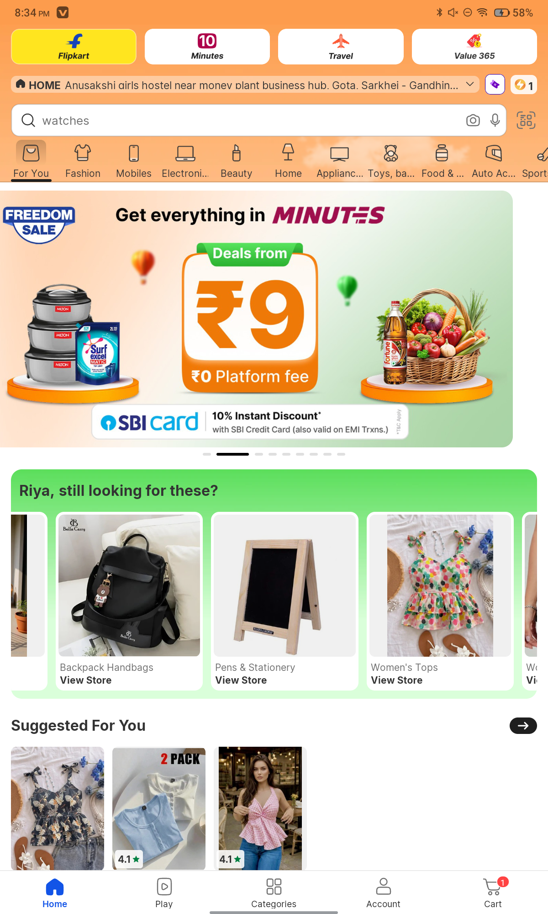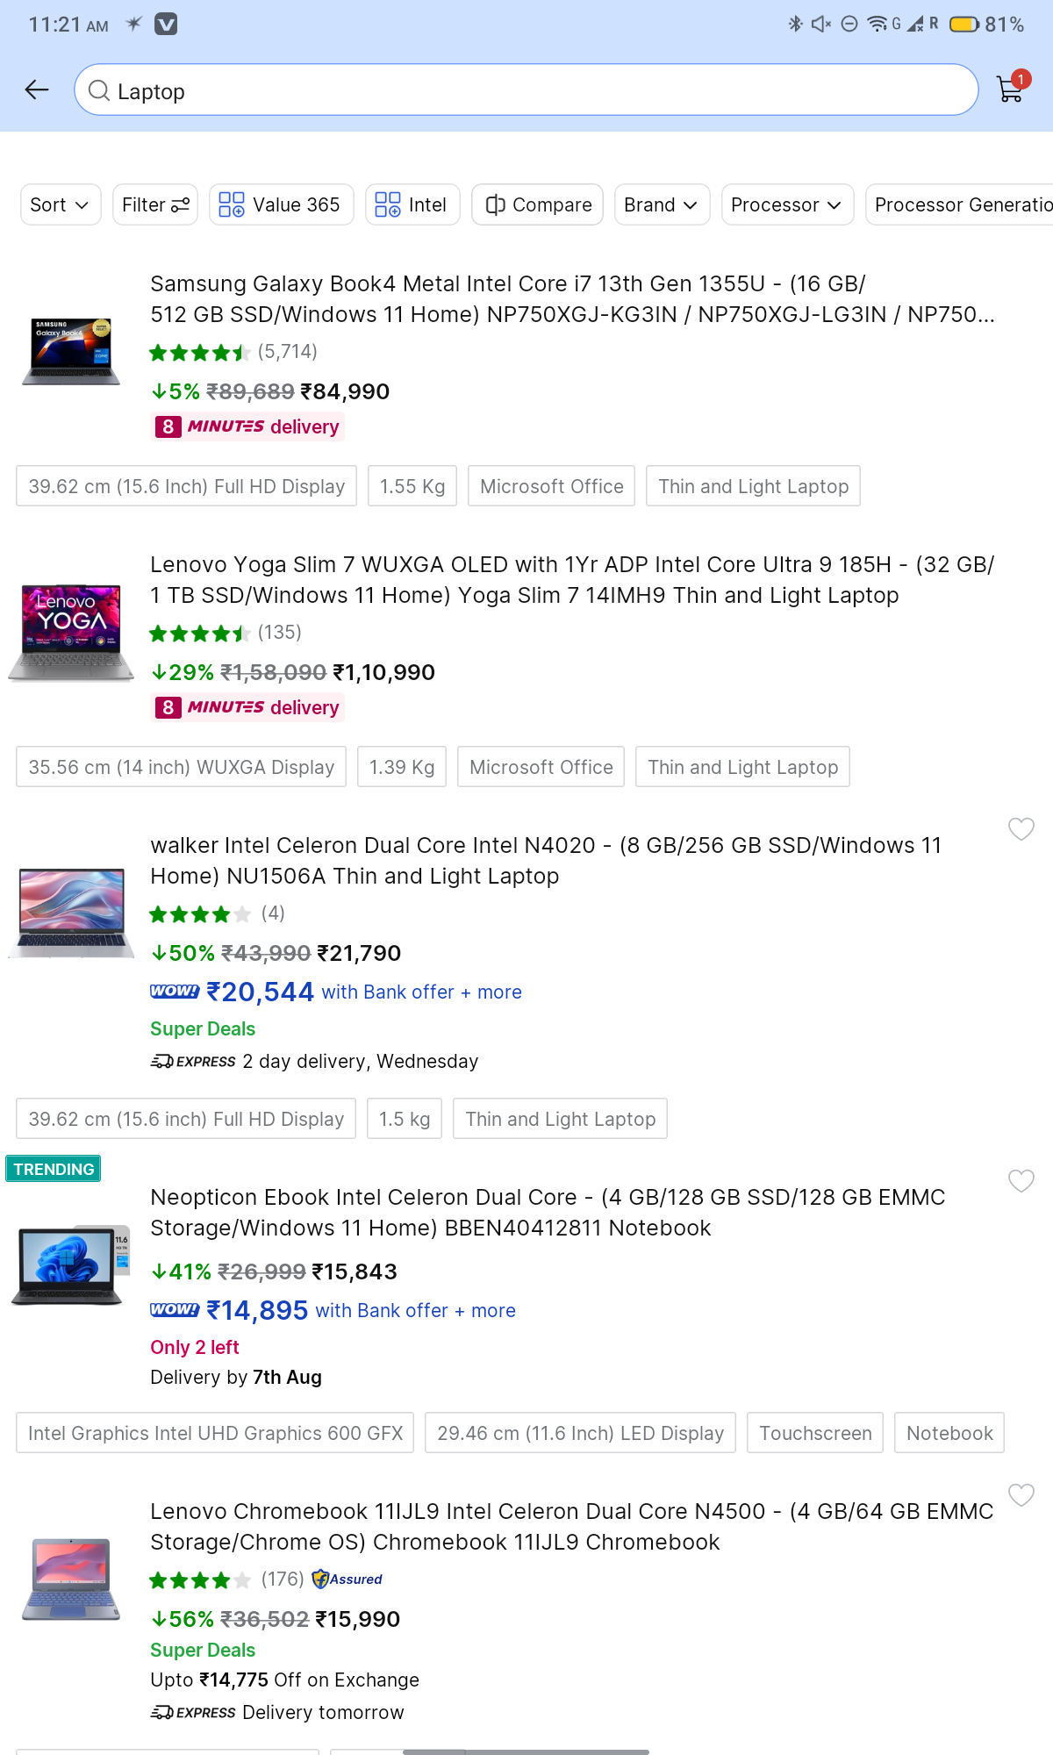
Scenario 1b
Scenario: Search using an invalid/random keyword
- Steps
- Enter "xyz123abcd"
- Click Search
Screenshots:
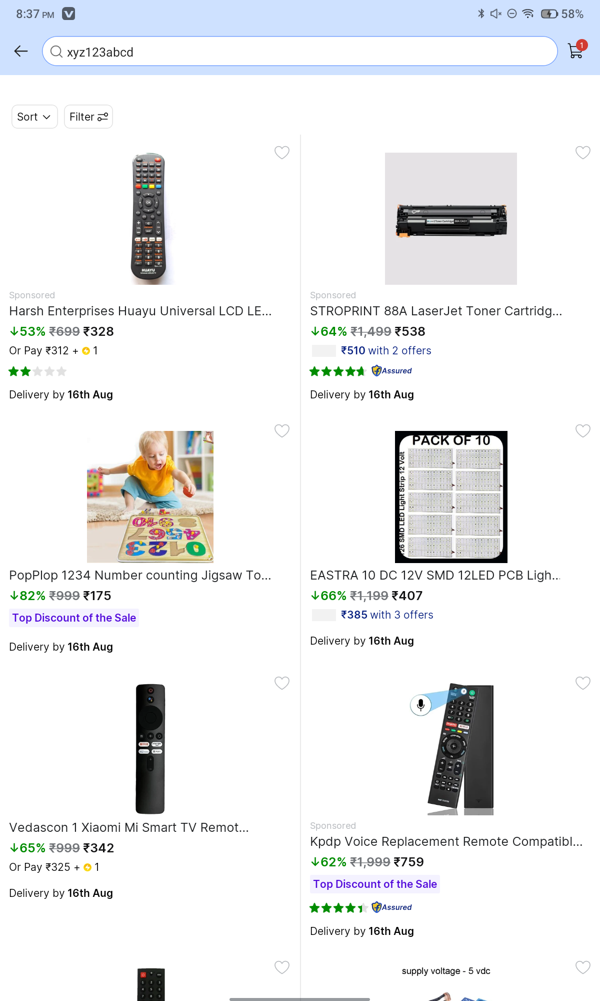
Scenario 1c
Scenario: Search using an empty search field
Steps
- Leave search box empty
- Click Search
Screenshots
Scenario 2a
Scenario: Open a product page
Steps
- Search Laptop
- Open first product
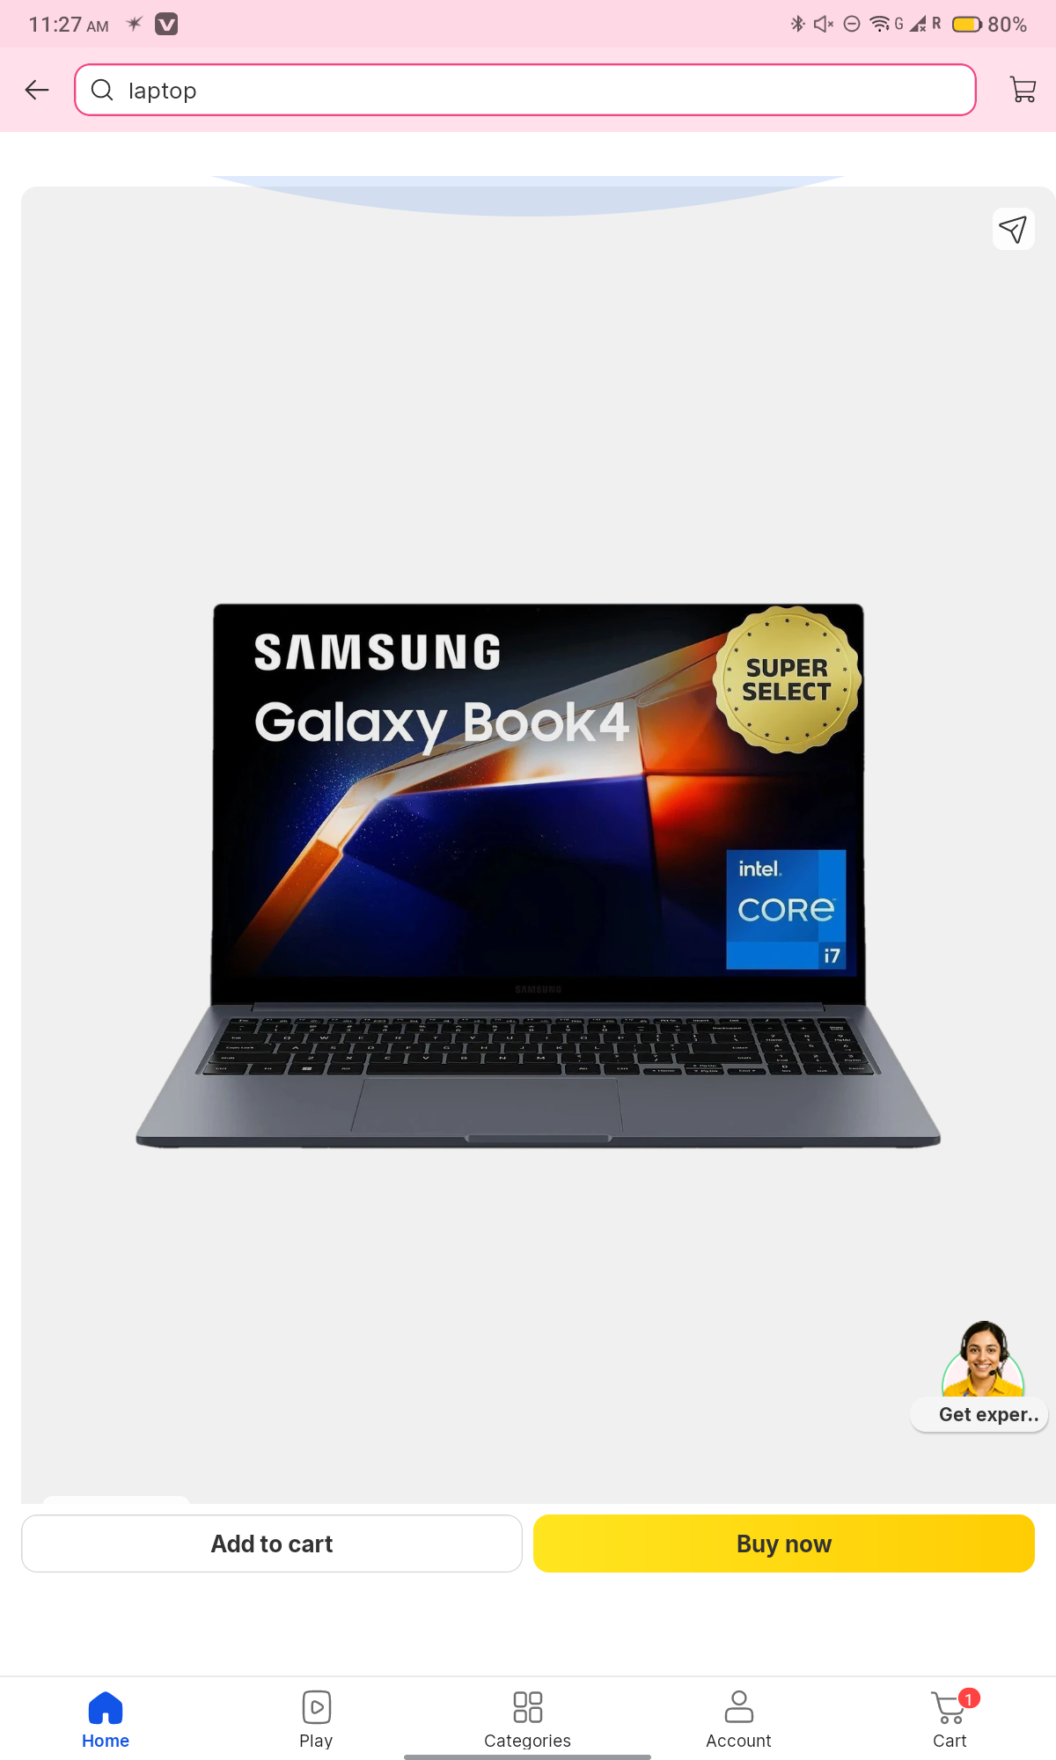
Scenario 2b
Scenario: Verify Login page
Steps
- Click Login
- Enter invalid mobile number
Screenshots
